15.Write a Pandas program to keep the rows with at least 2 NaN values in a given
Data Frame.
Code:
import pandas as pd
import numpy as np
data = {
"A":[1,np.nan,np.nan,4],
"B":[np.nan,np.nan,7,8],
"C":[9,np.nan,np.nan,np.nan]
}
df = pd.DataFrame(data)
result = df[df.isnull().sum(axis=1)>=2]
print(result)
Output:
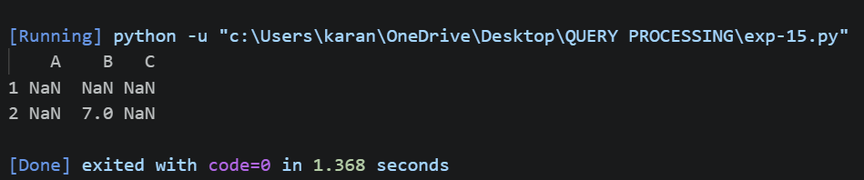
16.Write a Pandas program to split the following dataframe into groups based on school
code. Also check the type of GroupBy object.
Code:
import pandas as pd
df = pd.read_csv("school.csv")
group = df.groupby("School_Code")
print(group)
print("\nType of GroupBy Object:")
print(type(group))
Output:
